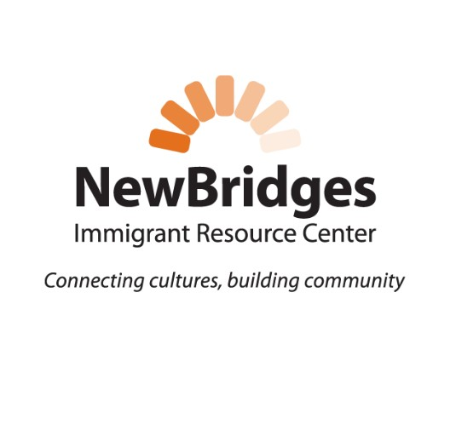
• All new Board members will be given an orientation and assigned a Board mentor who has served longer than one year.

Prospective Board Member Information
Name:
Mailing Address:
City/State/Zip:
Country (if not USA):
Cell Phone:
E-Mail:
Profession/Title/Employer (as applicable):
Community Organizations you are Engaged with (ex. House of Worship, Rotary, Clubs, etc.):

Areas of Expertise

AREA | NOTES
Accounting/Banking
Board Governance
Entrepreneurial/Business Experience
Human Resources
Immigration Experience
IT Knowledge
Non-profit Development
Legal Expertise
Public Relations
Writing/Editing

Your “Why”

Why do you want to serve on the board of directors for this organization?

Why do you believe you will be a good fit with the mission and work of NewBridges Immigrant Resource Center?

Please complete this document and submit along with resume to the Board Chair:
nbircchair@gmail.com

THANK YOU!
We look forward to talking with you!

